Customer Shopping Behavior Analysis

1. Project Overview

This Project analyzes the behavior of customer shopping using around 3,900 customers that purchases various product along different categories. The objective of this project was to analyze customer purchasing behavior, spending patterns, demographic segmentation, and subscription trends to identify high-value customer groups and revenue growth opportunities for an e-commerce business.

2.Dataset Summary

-Rows 3,900
-Columns 18
-Key features:
-Customer Demographics [Age, Gender, Location, Subscription status]
-Purchase Detail [Item purchase, Category, Purchase amount , Size, Color, Season]
-Shopping behavior [Shipping Type, Discount Applied, Promo Code Used, Previous Purchases, Payment Method, Frequency of Purchases, Review Rating]
-Missing data - 37 values in Review Rating column

3. Data analysis using python

We begin with data processing and cleaning in Python.

Data Loading : imported dataset using pandas
Here below the view some rows and column of data
Used df.info() to check Structure and describe.() to check for summary
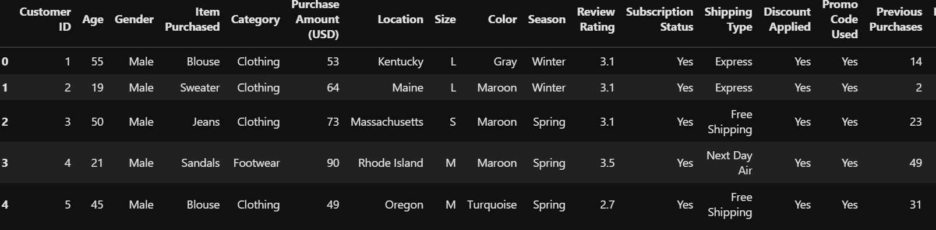

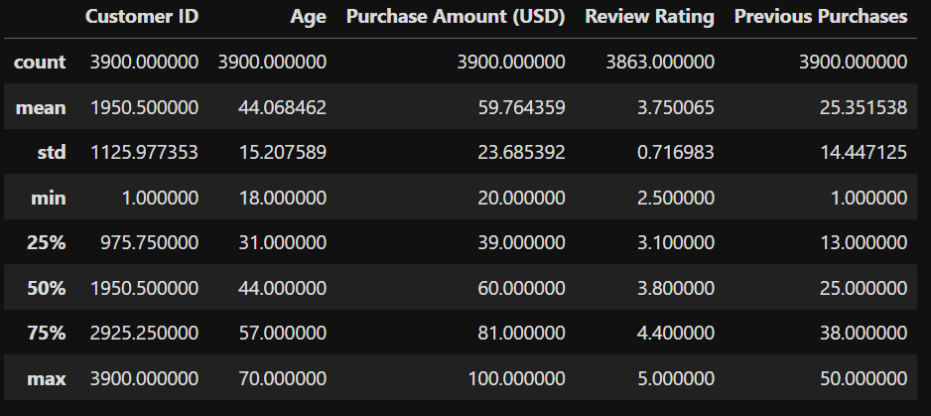

Missing data handling : checked for null value in data and find the 37 null values in Review Rating column. Fixed this value using Median rating of each product category

- Column Standardization : Renamed Columns to lower case for better readability
And documentation

- Feature engineering

Created Columns named age_group for agedwize analysis

Created purchase_frequency_days Column from purchase data

- Data consistency checked

Verified if Discount Applied and Promo Code Used
Were redundant ; dropped Promo Code Used

- Database integration

Connected the python script to Postgres SQL and loaded the nit and cleaned Data
Into Database for further analysis in SQL

4 Data analysis using SQL
We perform various operations on dataset using SQL queries and answer some key business questions

1. Which age groups have the highest Average Order Value and Subscription Rate?

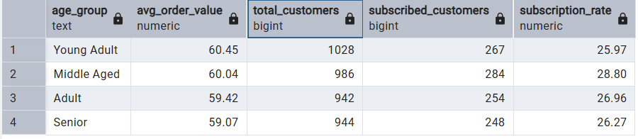

2. Which product categories require discounts to generate higher revenue and which sell well without discounts?

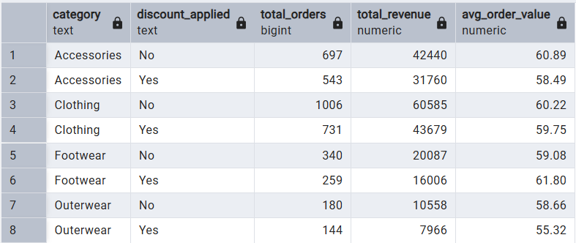

3. Which are the top products with the highest review rating but still low revenue?
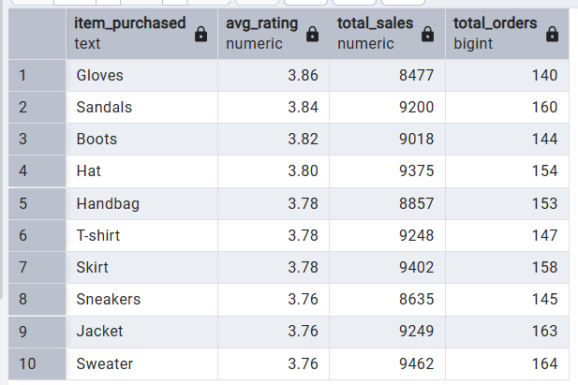
4. Compare the average Purchase Amounts between Standard and Express Shipping.
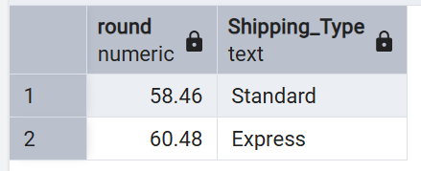

5. Do subscribed customers spend more? Compare average spend and total revenue between subscribers and non-subscribers.

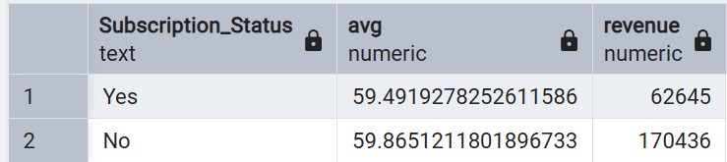

6.Which 5 products have the highest percentage of purchases with discounts applied?
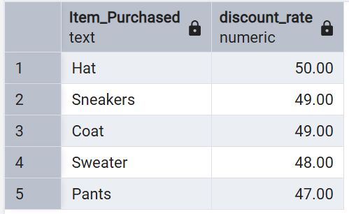

7. Segment customers into New, Returning, and Loyal based on their total number of previous purchases, and show the count of each segment.
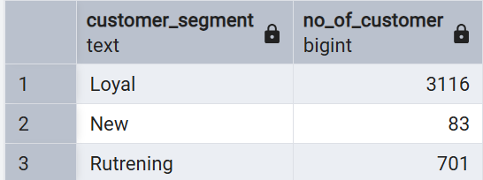

8. What are the top 3 most purchased products within each category?
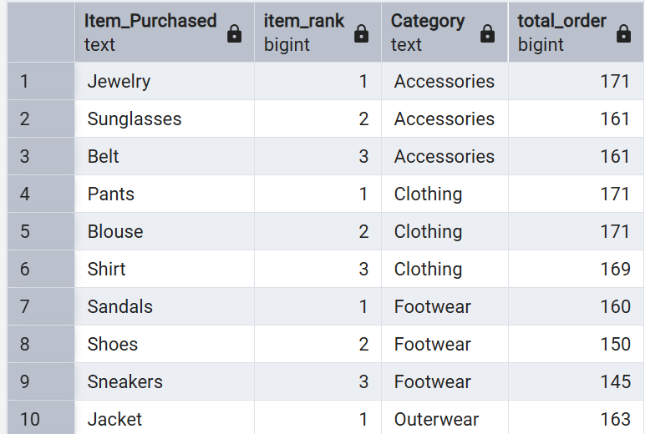
9.Are customers who are repeat buyers (more than 5 previous purchases) also likely to subscribe?

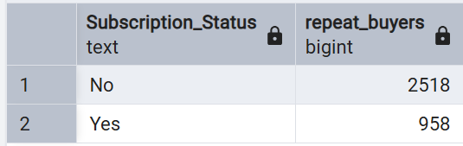

10.What is the revenue contribution of each age group?

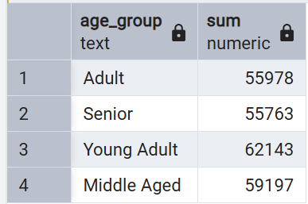

11. top revenue-generating customer in each location.
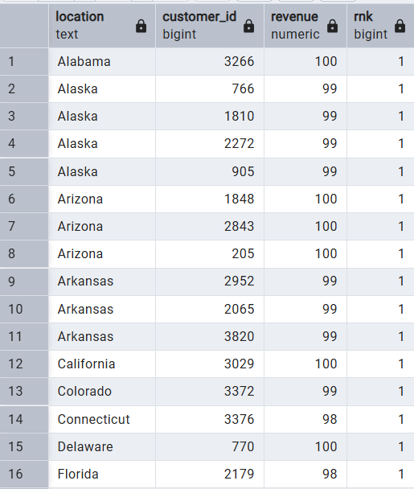

5 Dashboard using Power bi

- Use of Visuals to visualized data set and create interactive dashboard
Where we can easily see our expected information

Below the Dashboard of Customer behavior Analysis
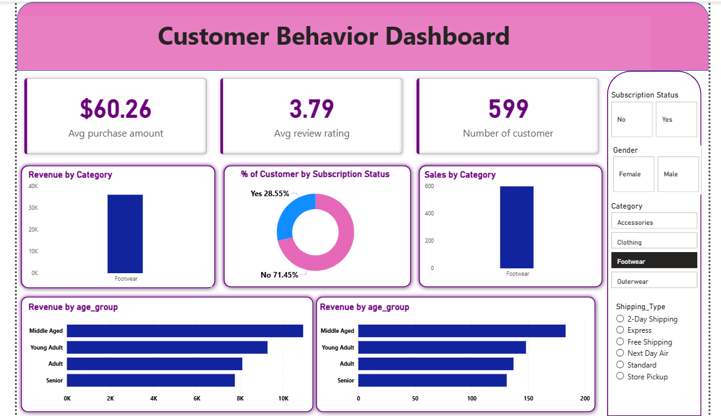

6. Key Business Insights & Recommendation

Insight | Recommendation
Subscribers spend 28% more than non-subscribers. | Launch targeted campaigns to convert high-spending non-subscribers into subscribers.
Clothing contributes the highest revenue. | Prioritize inventory and marketing investment for the Clothing category.
Customers aged 25–35 have the highest average spending. | Allocate a larger share of digital marketing budget toward this age group.
Highly rated products have relatively low sales. | Increase visibility through homepage placement and promotional campaigns.

7 Project Limitations
• The dataset contains one record per customer, so transaction-level analyses such as RFM Analysis, Cohort Analysis, and Customer Lifetime Value (CLV) cannot be performed accurately.

• Purchase history over time is not available, making it impossible to analyze customer retention, repeat purchase behavior, or seasonal buying patterns.

• The dataset is static and does not include real-time or continuously updated customer transactions.

• Customer profitability and operational costs are not included, so profit margin analysis cannot be performed.

• Customer feedback is represented only by numerical ratings, without written reviews for sentiment analysis.

8 Future Scope

Use a transaction-level dataset with multiple purchases per customer to perform RFM Analysis.
Build a Customer Churn Prediction model using historical customer behavior.
Estimate Customer Lifetime Value (CLV) to identify high-value customers.
Perform Cohort Analysis to measure customer retention over time.
Develop a recommendation system to suggest products based on customer preferences.
Create an interactive Power BI dashboard connected to a live database for real-time reporting.
Incorporate external data such as holidays, promotions, and marketing campaigns to improve business insights.

